**Connoisseur: Free Website Template**

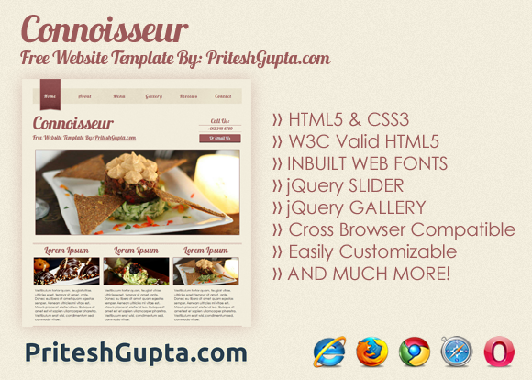

“**Connoisseur**” is a **bold** and **modern** website template suitable for websites pertaining to fine arts, cuisines, dining etc. It is **cross browser compatible** made using **HTML5** and **CSS3** with inbuilt **web font**, necessary **jQuery plugins** and much more. You are free to use it for your personal as well as commercial projects. It is released under **New BSD License**, read more about it at <http://www.opensource.org/licenses/bsd-license.php>.

**Release Page at** [**http://www.priteshgupta.com/templates/connoisseur/**](http://www.priteshgupta.com/templates/connoisseur/)

**Customizing Individual Pages**

1. Open the respective html files within the folder “Connoisseur” using any WYSIWYG or text editor.
2. Replace the default text and the default links.
3. Featured Slider should contain images of ratio 24:10.
4. Featured Images should also contain images of ratio 24:10.
5. No lightbox has been set for images for any page other than the “**Gallery**” page, to enable lightbox for images on other pages, simply follow the instructions at <http://fancybox.net/howto>.
6. All pages are by default with sidebar(except “**Gallery**” and **Home**”), to make any particular page full width, make sure that you have removed the <aside> section entirely and add the class “fullwidth” to the element article, that is, <article> should become <article class=”fullwidth”>.

**Typography**

The website is using “Lobster” font for headers. The other font being used is “Century Gothic”.

**For any other query, contact me via the contact form at** [**http://www.priteshgupta.com/contact/**](http://www.priteshgupta.com/contact/)**.**

